Дата: 26.05.2023 Клас: 6-Б

Предмет : Англійська мова

Тема: Повторення вивченого матеріалу

Мета: узагальнити та систематизувати знання, уміння та навички з тем «Країни та їхні столиці», «Лондон»; повторити правила уживання означеного та неозначеного артиклів, Present Simple,Past Simple та Present Perfect; розвивати навички читання; вживання граматичних структур в усному та писемному мовленні; сприяти формуванню комунікативної компетенції.

Вчитель: Глуговська Л.Г.

**Хід уроку**

***1.Greeting***

Good afternoon, dear children! I’m glad to see you. Are you ready to start our lesson? Let’s start.

1. ***Speaking***

*Дайте відповіді на питання.*

Ex.10 page 185

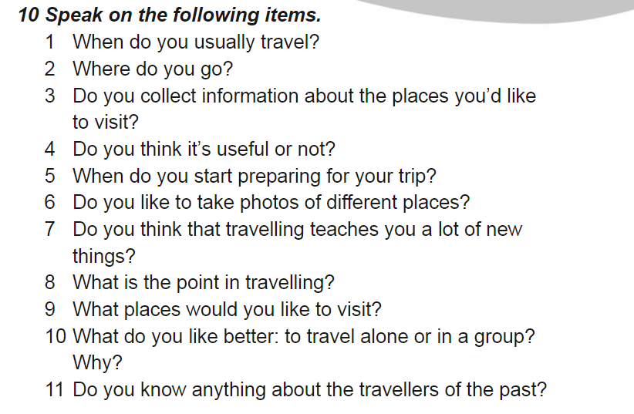

1. ***Grammar***

Повторюємо граматичні часи, розкрийте дужки та оберіть правильний варіант(усно).

**Open the brackets and put the correct tense form of the verb (Future Simple, Present Continuous, Past Simple)**

1. Tom ___ (not to eat) breakfast yesterday.
2. won’t eat b. doesn’t eat c. didn’t eat
3. His father __ (not to watch) TV at the moment.
4. am not watching b. aren’t watching c. isn’t watching
5. Where _ she __ (to be) tomorrow?
6. Will she be b. has she been c. is she
7. He __ (not to go) to the south a week ago.
8. didn’t went b. didn’t go c. didn’t goed
9. She __ (to enjoy) listening to his songs last night.
10. enjoyed b. has enjoyed c. enjoyes
11. Tom __ (to travel) around the world next year.
12. travels b. will travel c. has traveled
13. I __ (to be) very busy last summer.
14. was b. were c. been
15. I __ (to go) to bed at ten o’clock tomorrow.
16. went b. go c. will go
17. When _ you __ (to leave) home for school tomorrow?
18. are you leaving b. will you leave c. did you leave
19. Look! The baby __ (to sleep).
20. am sleeping b. is sleeping c. are sleeping
21. __ he __ (to play) now?
22. Did he play b. Is he playing c. Will he sleep
23. __ granny _ (to cook) dinner now?
24. Is granny cooking b. Did granny cook c. Will granny cook

***4. Reading***

*The Houses of Parliament*

Its official name is the Palace of Westminster. Most of the building was built in 1840 after a fire in 1834 destroyed the old palace. At the north end of the building by Westminster Bridge is the famous clock tower, Big Ben.

*The National History Museum*

Situated in Kensington. One of London’s greatest museums. A huge collection of animals and plants, including a quarter of a million butterflies, a blue whale and the famous dinosaur skeletons. Cafeteria, gift shop and book shop. Open daily 10 — 5.45.

*Madame Tussaud's Museum*

This famous waxworks has models of famous people from pop stars to prime ministers. Displays of battles and Chamber of Horrors. Gift shop.

Open every day 10 — 5.30, except Christmas Day.

***5. Homework***

Домашнє завдання:

1. Опрацювати матеріал конспекту.

***Хай щастить!***